Odd Semester (2023)



|  |
| --- |
| **Assignment Cover Letter**    **(Individual Work)** |

**Student Information**: **Surname**  **Given Names Student ID Number**

1. **Edgari** **Eric** **2301902352**

**Course Code**  **: COMP6510**  **Course Name**  **: Programming Langguages**

**Class** **: L2AC**   **Name of Lecturer(s)** **: Jude Martinez**

|  |
| --- |
|  |

**Major**  **: CS**

**Title of Assignment** : Money Managemetn GUI

(if any)

**Type of Assignment**  **: Final Project**

**Submission Pattern**

**Due Date** **: 20-06-2020**  **Submission Date** **: 20-06-2020**

The assignment should meet the below requirements.

1. Assignment (hard copy) is required to be submitted on clean paper, and (soft copy) as per lecturer’s instructions.
2. Soft copy assignment also requires the signed (hardcopy) submission of this form, which automatically validates the softcopy submission.
3. The above information is complete and legible.
4. Compiled pages are firmly stapled.
5. Assignment has been copied (soft copy and hard copy) for each student ahead of the submission.

**Plagiarism/Cheating**

BiNus International seriously regards all forms of plagiarism, cheating and collusion as academic offenses which may result in severe penalties, including loss/drop of marks, course/class discontinuity and other possible penalties executed by the university. Please refer to the related course syllabus for further information.

**Declaration of Originality**

By signing this assignment, I understand, accept and consent to BiNus International terms and policy on plagiarism. Herewith I declare that the work contained in this assignment is my own work and has not been submitted for the use of assessment in another course or class, except where this has been notified and accepted in advance.

Signature of Student: (Name of Student)

**“Money Management”**

**Name : Eric Edgari**

**ID : 2301902352**

**I. Project Specification**

**The reason I make this program:**

I made this program because I want to keep track all of my spending and regularly buy stock monthly

**The function of this program:**

The purpose of this program is to keep track how much I saved and spent weekly and monthly , and every week I will send 20% of my saving to my stock account

**Class diagram**

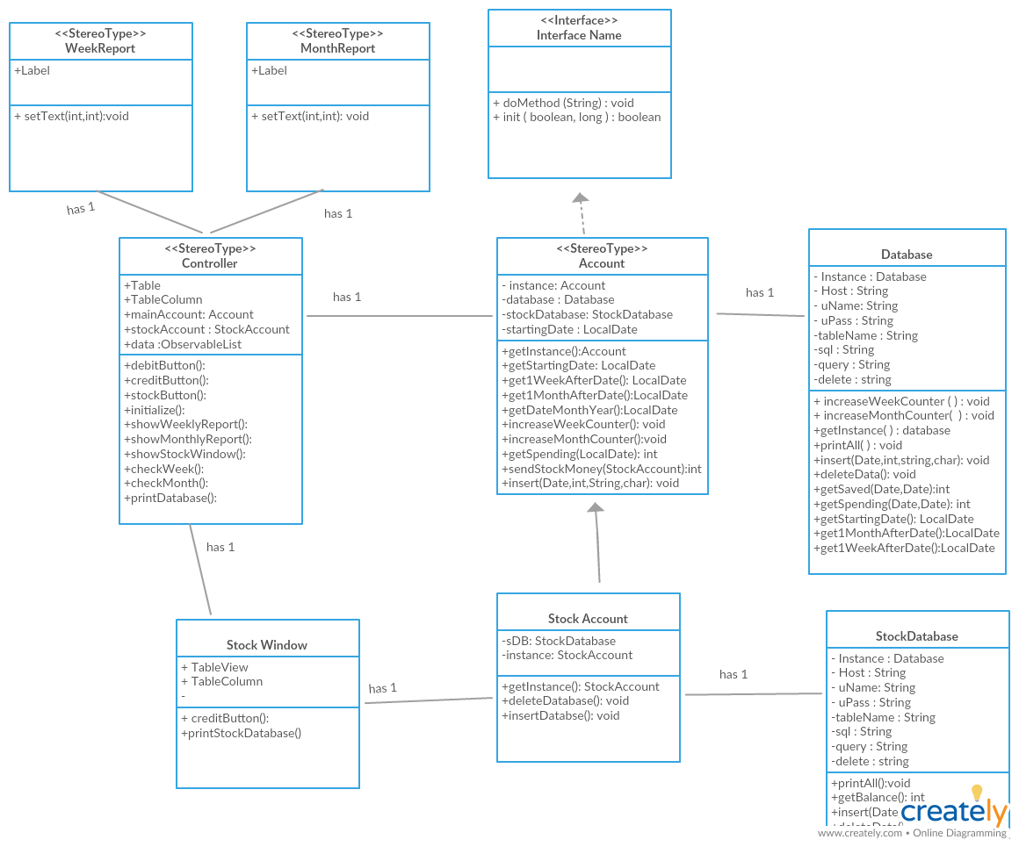

**Solution Scheme**

1. On the starup program , check if its time for weekly report , or monthly report , if it is show the report
2. Taking user input for debit to increase saving or taking user input for credit to increase spending, after that store it to the database
3. Stock account to go make a stock account appeared on the window
4. Have credit button , taking input from userto reduce stock account balance ,

**Algorithm**

1. Check the week if it’s already one week passed since the stating date , the starting date is the first date that the database is inserted , and if its true , show the weekly report and send money to the stock account . for the next week , we increase the starting date by a variable called weekcounter , basically it increase everytime the show weekly report window is called
2. Check the monthly report , it’s the same as check the week , but it is on monthly basis , rather than increase one week , it increase one month , and it don’t have any feature of sending money , cause I don’t need to send a monthly money to the stock account
3. If debit button clicked , we get the amount and information of the transaction from the text field , and add the data first to the observable list to display in GUI and insert It to the database on mysql
4. Credit button works the same , but it insert a credit value to the mysql database
5. Stock button works to make a stock account window pop up , in there you have the credit button , it works the same , but it inputted the data to the StockAccountDatabase

**Data Structure**

The data structure that I mainly use is mysql database , basically I already made a table in mysql workbench , and insert it to the databse , I have 2 different table for my sql databse . I made the different table a different class, to really differentiate the two different account , because in real life , it is a 2 different object

I also used the observable list for the GUI to keep track if I add more to the list . it will kept updated , but it only accepts an object of that data , so for 1 row of data/ transaction , I need to make it to an object , and insert it to the observable list .

**Proof of working Program**

Monthly report shown

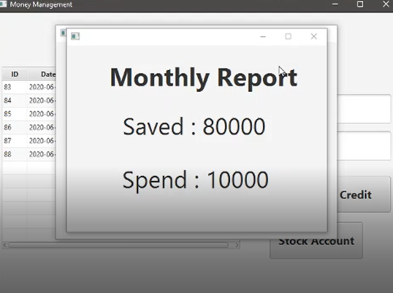

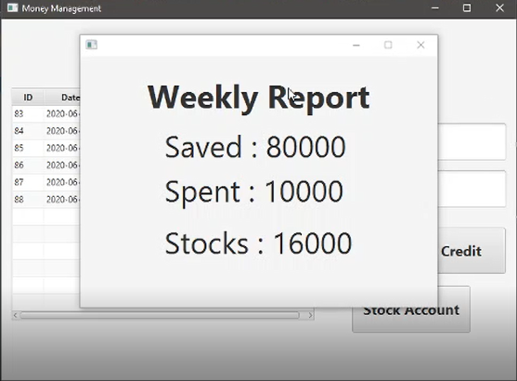Weekly report Shown

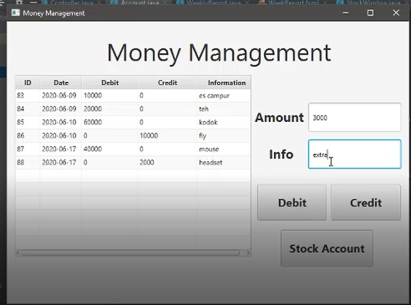

Main window / main Account

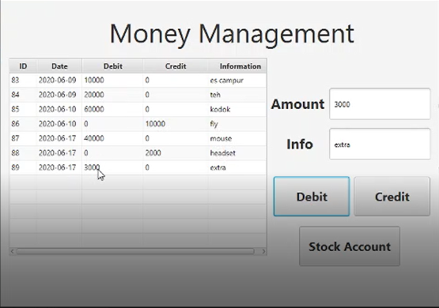

Debit Button clicked , data added

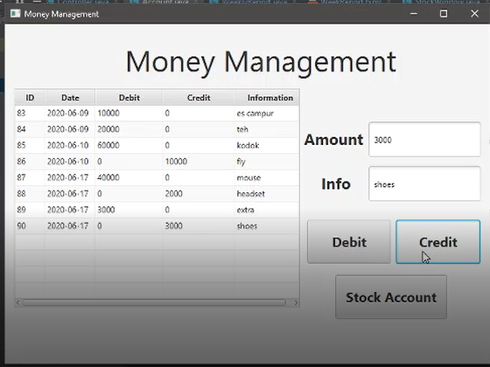

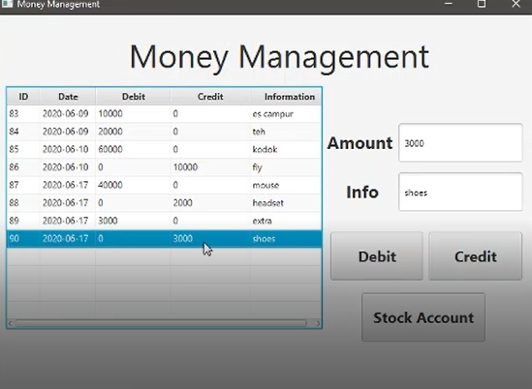

Credit button clicked , data added

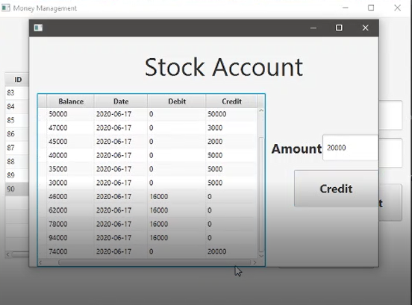

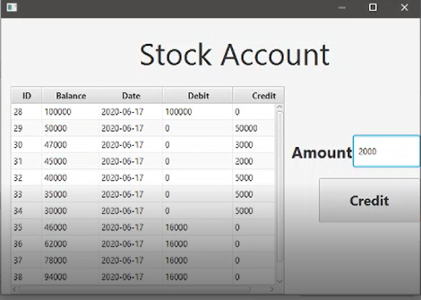

Stock Account button , pop up stock account window

Credit button clicked , and the added data

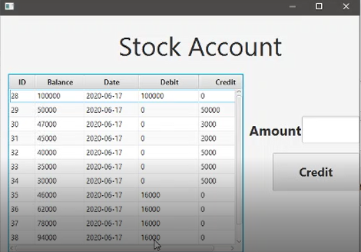

Resources:

<https://www.youtube.com/watch?v=8WJ5p3T9Iss>

java fx tutorial and mysql

<https://stackoverflow.com/questions/23949067/how-to-make-javafx-app-always-on-top-of-other-applications?rq=1>

how to make windows pop up always on top

<https://www.genuinecoder.com/javafx-communication-between-controllers/>

how to get the controller for the other windows

[**https://stackoverflow.com/questions/27079062/javafx-event-argument-type-mismatch**](https://stackoverflow.com/questions/27079062/javafx-event-argument-type-mismatch)

debugging , just to find out it was a typo error

<https://stackoverflow.com/questions/14413040/converting-integer-to-observablevalueinteger-in-javafx>

debugging , just to find out it was typo error / syntax error

<https://docs.oracle.com/javafx/2/installation/jfxpub-installation.htm>

how to install java fx to intellij ide, java fx for making the GUI

<https://stackoverflow.com/questions/29750861/convert-between-localdate-and-sql-date>

how to convert local data to sql date

<https://stackoverflow.com/questions/28948579/how-to-debug-you-have-an-error-in-your-sql-syntax-in-mysql>

syntax error for my sql ,

<https://stackoverflow.com/questions/12144441/how-to-debug-an-error-in-sql-syntax>

syntax error for mysql

<https://dev.mysql.com/doc/refman/5.6/en/char.html>

how to use mysql / mysql documentation